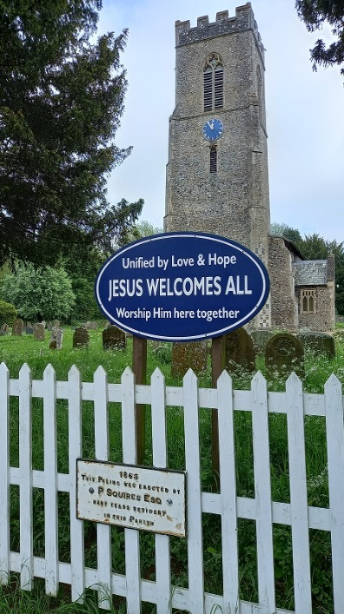**CHURCHYARD**

**TRAIL**

**WELCOME** to Mulbarton churchyard.   
Points of interest are numbered on this trail. If it helps, there is a map in the porch to borrow, and a plant list.

[1] We begin near the gate by the road where the noticeboard is located. To your right is an oval blue WELCOME notice to our parish church.

Before you enter the gate, notice….

The land in front of the white fence is common land. On the fence below the WELCOME board is a plaque with the date and donor of the fence – erected 1863 by Paul Squires, a resident of Mulbarton Hall from about 1840.

Look right – [2] the footpath cutting off a corner of the churchyard was created in the early 1980s by the Parish Council at the request of the church after a child was hit by a car between the church and the old Village Hall on their way home from Sunday School.

Look UP at the yew trees [3]. YEW TREES are incredibly long-lived: 10 yew trees in Britain are thought to predate the Norman Conquest (1066). They are classed as conifers, but never bear cones; they are classed as soft-wood but are probably the toughest European wood, valued for making longbows.

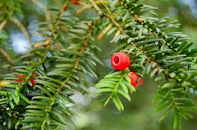Take a close look – But BEWARE – yews contain highly poisonous taxane alkaloids that have been developed as anti-cancer drugs. Eating just a few leaves can make you seriously ill and ALL parts of the tree are poisonous to humans.

What do the leaves look like? How are they arranged on a stem? Can you spot any flowers (March – April) or fruit (red, berry-like, see photo)? Yew trees are male or female, although it is hard to tell the difference except from the flowers.

Come through the gate and take the path to the LEFT of the church. Look UP at the tower [4]. The clock is the World War 2 war memorial, dedicated 8th October 1950 and refurbished by the Parish Council in 2020.

Take a closer look at the building material: the tower tells us a lot about local geology. It is mostly made of local black FLINT - a rock that occurs in chalk. The mortar is made from local CHALK. Flints are too small to make good corner-stones, so these are of LIMESTONE from Lincolnshire - 100 miles away. The flints in the buttresses have been skilfully knapped by hand to make them square. There are a few non-local stones. These are almost certainly GLACIAL ERRATICS - stones brought to Mulbarton from northern England by ice-sheets in the Ice Age. The BRICKS AND TILES in the tower are unusual - there were no bricks or tiles being made in England at the time this tower was built, so they are probably from the ruins of Caister Roman town, 3 miles to the north-east. If so, they date from roughly the time when Jesus was on earth...

There is a different range of rocks among the headstones in the churchyard. As you walk around, look out for white limestone; red sandstone; pink, grey or black granite, speckled with other minerals; marble and slate. If they carry a recent date they may well have been imported, but stones that are more than 100 years old are likely to have come from British quarries. Notice the different rates of weathering – many older stones are almost illegible now. Notice, too, which stones are dotted with LICHEN. These are complex life formed from two separate organisms, a fungus and an alga. They may hide inscriptions, but they actually protect the stone from the weather and some of the lichens here may be ancient and rare.

As you pass the church, look RIGHT [5] – you are looking at the Victorian North Aisle added in 1875. Notice the buttresses…. Can you spot the one that was once a chimney for the coal-fired heating system? Today the heating comes from air-source heat pumps sited between the north aisle and the vestry – a much ‘greener’ option and part of our plan to be an eco-friendly church.

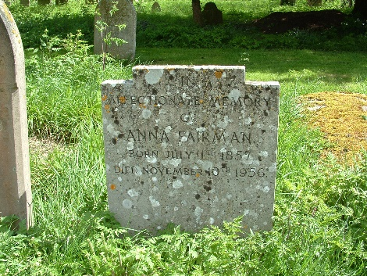To the right of the path is a row of 3 crosses [6], memorials to the Hackblock family who lived at The Lodge, Rectory Lane, from the 1870s to 1890s. A little further on, also on the right, is the grave of Anna Fairman who died in 1956 aged 99. She farmed at Malthouse Farm, by the south-west corner of the Common. Her photo is here: <https://www.mulbartonhistory.org.uk/malthouse/>

Looking LEFT, the north area of the churchyard, extending beyond the Rectory garden, was added at the end of the 19th century – the oldest grave seems to be one dating from 1899.

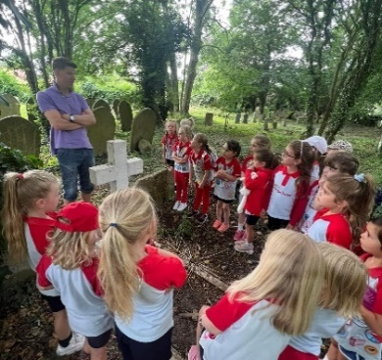To the LEFT of the path [7], behind a sycamore tree, is our only WAR GRAVE,

that of Frank Barrett (1897 – 1920), a gunner with the Royal Horse Artillery. He died in Norwich as a result of war service. Look for the white cross. The photo *(left)* was taken when the Rainbows cleaned the grave before Remembrance Sunday.

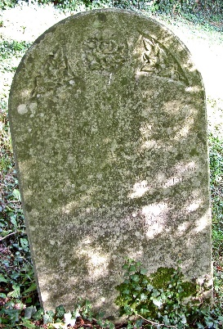Other men killed in action in World War 1 are commemorated on family headstones although buried elsewhere. As you reach the entrance to the churchyard extension, to the right by stump of felled ash tree [8] are headstones for the Stackyard family. Among them is a dedication to William Stackyard who was killed at Gallipoli in 1915. You can read their names on the war memorial in the church and there are more details at <https://www.mulbartonhistory.org.uk/ww1-men-at-war/>

Before entering the newest area, notice on the LEFT [9] the CHERRY tree planted in 2024 as a memorial for babies who died before or soon after birth. There are a lot of inscriptions on headstones for young children, not all of whom died in the days before modern maternity care and inoculations became available. Nearby is a seat – why not sit awhile and LOOK at the plants and birds and LISTEN to the birds?

Follow the path into the churchyard extension – added in 1989 but already well ‘populated’. The hedge to the left and right of the entrance contains a number of tall ASH trees. A bird box will be placed in one Ash tree to the left of the entry, and another in a tree in the opposite hedge.

Walk toward the far righthand corner ([10] near a large access gate). On your way, you may find some small blue flowers along the far hedge-line: FORGET-ME-NOTS and SPEEDWELL.

In the corner, near the gate [10] you can see the Millenium YEW. When this was planted in the year 2000 it was a cutting about 20 cms tall, and a few centimetres wide. It was taken from a tree that was 1000 years old. How tall and wide is it now, after nearly a quarter of a century?

Return to the older part of the churchyard and in about 10 metres (opposite [9] the memorial tree) turn LEFT along a path beside a row of mature yew trees. These mark the boundary of the oldest part of the churchyard. The strip of land between these trees and the hedge was the first churchyard extension, added in the mid-1800. A short way along, look LEFT [11] to notice a large pink granite memorial near the hedge, under a large ash tree. Worth taking a closer look, if access is not too overgrown by nettles. This is the resting place of Sir William Bellairs who died in October 1876, and his wife Cassandra 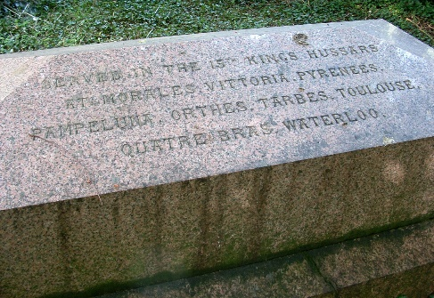who died a month later. Sir William served in the 15th Kings Hussars and on one side of his grave are listed the battles in which he fought against Napoleon, including Waterloo. Lady Bellairs is recorded as the daughter and heiress of Edmund Hooke whose tomb we shall pass later. These fascinating families lived at The Lodge in Rectory Lane and there is more about them at <https://www.mulbartonhistory.org.uk/the-lodge/>

Just after a large HOLLY tree you may notice to your LEFT [12] two granite crosses with inscriptions on their plinths to John Riches Draper (died 1906) and his wife, Mary Ann Draper (died 1922). They lived at Mulbarton Old Hall (the Manor House), very close to the churchyard, where they were tenants of the Steward family, the Lords of the Manor. There is a photo of the family at <https://www.mulbartonhistory.org.uk/the-manor-house/> Nearby are graves of the Muskett family, market gardeners at Hill House, Norwich Road – their son Cecil, killed in France in 1917 aged 20 is listed.

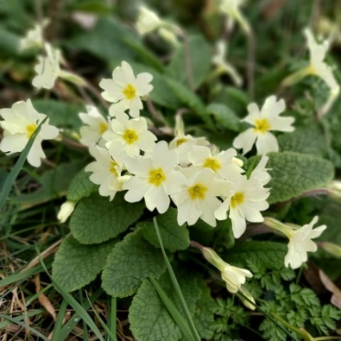Stop and LOOK around. In the Spring the area along this path is filled with a mass of primroses and bluebells. The Latin name of the PRIMROSE is ‘Prima Rosa’ which means first rose of the year. Although it is not really a rose it is also called Lent Rose or Easter Rose. Primrose Day is 19th April. In folklore it was thought that if you wore a wreath of BLUEBELLS you would be compelled to tell the truth. Bluebells have been used for medicinal purposes and the mucilage (a thick gluey substance found in the bulb) was used in the past as an adhesive and for stiffening fabric.

Look RIGHT, close to the east end of the church [13] are rows of graves of the Turner family who lived and farmed at Paddock Farm and Kenningham Hall. TAKE CARE of rough ground and hidden stones if you approach this area – and many of them are listed on two plaques inside the church, above the war memorials.

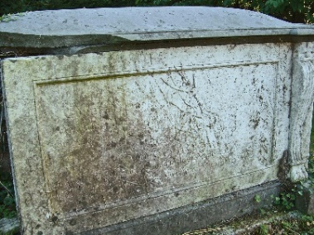Turn RIGHT along the public footpath. The ivy-covered hedge on your LEFT is made up of Hawthorn. HAWTHORN wood was said to prevent lighting strikes and to burn the hottest of all firewood. Water distilled from Hawthorn fruits was used to draw splinters from the skin. Hawthorn blossom was not usually welcomed in the house. The flowers were said to smell of death. The flowers do contain the chemical trimethylamine which is also present in decaying animal tissue.

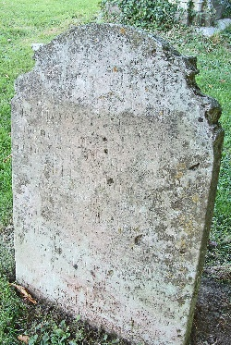Not far from the gate, on the RIGHT [14] is the large sarcophagus to Edmund Hooke, Esq., Barrister at Law who died in 1811. It is not easy to read, but commemorated here are several children and his wife Naomi who remarried and died at a health resort in the French Pyrenees in 1830. The family lived at The Lodge. Just past their grave is a memorial to Lydia Tyrrell, now almost illegible. She died in 1831 aged 89, and her stone was erected by Miss Hooke to commemorate ‘an old faithful and affectionate nurse’. A reminder that buried in the churchyard are people of all ranks and backgrounds, many of whom were too poor to have a memorial.

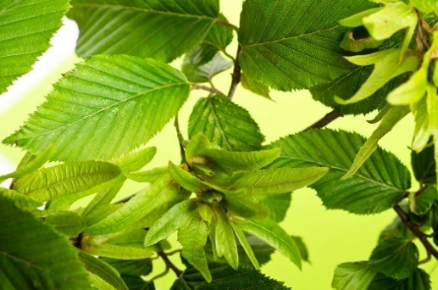Look UP at the HORNBEAM tree near the gate. Its pale toothed leaves are quite a contrast with the yew! In the autumn it produces winged fruit.

Turn RIGHT up the gravel path towards the church porch [15]. This was once much larger but reduced in size when the church had a Victorian make-over. Do come in and take a look round: there are paper guides, and a ‘Virtual Tour’ at <https://www.mulbartonhistory.org.uk/parish-church/>

The rose bush opposite the porch [16] was planted in memory of Mabel Gertrude Hooney who died in 1961, although the plaque is now lost. The Hooney family ran a rose nursery in the southern part of the village which gave its name to The Rosery.

Walk back to the main gate.

The areas either side of the main gate are now being managed as conservation areas. They will be left uncut until late summer when they will be mown and the cuttings removed as this is the best way to encourage more flowers and biodiversity. Some of the flowers you can find in these areas, and possibly elsewhere in the churchyard, in the summer include Lady’s Bedstraw, Yarrow, and Ox-eye Daisies.

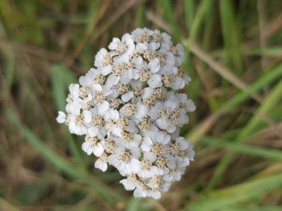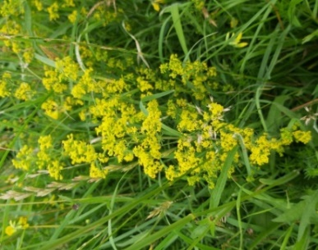LADY’S BEDSTRAW (left*),* when dried, smells sweet and was used to stuff mattresses or strewn on floors. It was also used to curdle milk during cheese making.

YARROW *(*right*)* has properties that help stem bleeding and was even used to help heal wounds in the First World War when regular medicines were in short supply.

Churchyards are important habitats because they have not been cultivated for a thousand years or more. Mulbarton is registered as an Eco Church and we are seeking to encourage a greater diversity of plant and animal life, thanks to the help of the Norfolk Wildlife Trust.

If you spot any interesting birds, bugs, animals or plants please let us know by contacting [heather@mulbchurch.org.uk](mailto:heather@mulbchurch.org.uk).

If you would like to help us in any way to achieve the Eco Church Bronze Award we would welcome your suggestions as well as any practical help you could offer such as building a bug hotel or joining us to rake off the hay from the conservation areas. Leave your contact details at the Rectory, Harvest House or by emailing the above address.